* Theme: light + (default light)

**1. Introduction**

* Shell scripts are interpreted not compiled
* To see installed shells in your machine
  + cat /etc/shells
* sh is borne shell….still used in unix system, the first shell which was used
* bash ...born again shell…. Standard gnu which is intutive and flexible
* to see where bash is located
  + which bash
* #! shebang/hashbang

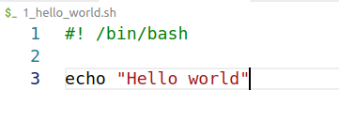

**2. Using Variables and Comments**

* Two types of variables
  + system variable (Capital case)
  + user defined variables

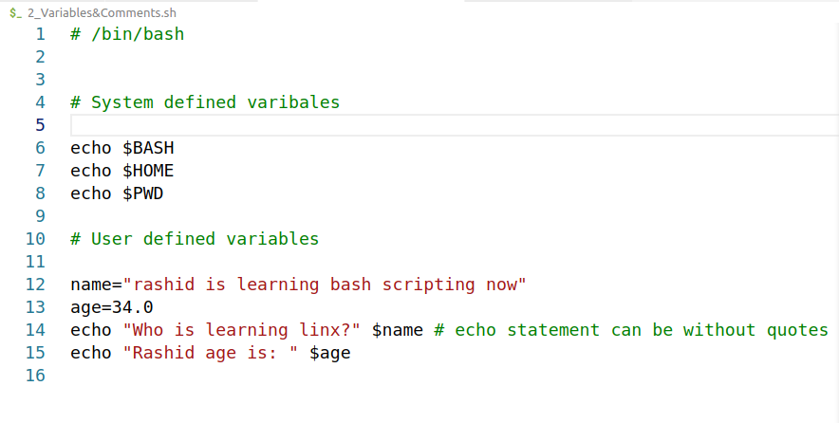

**3. Read User Input**

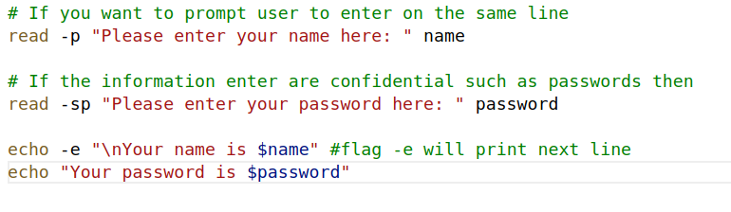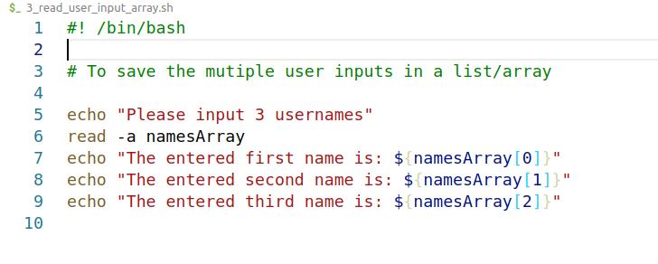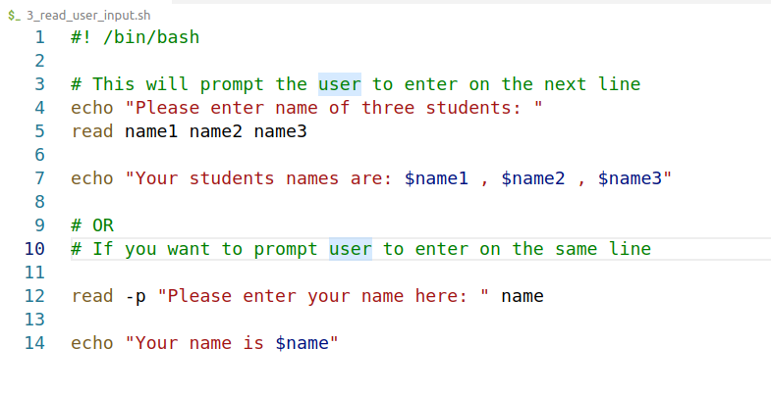

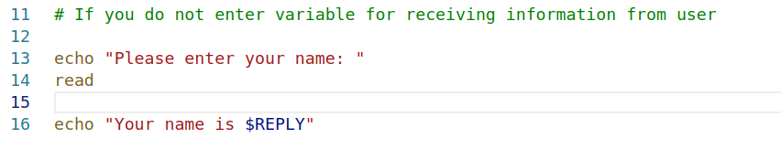

**4. Pass Arguments to a Bash Scripting**

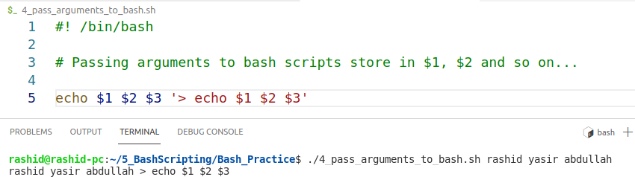

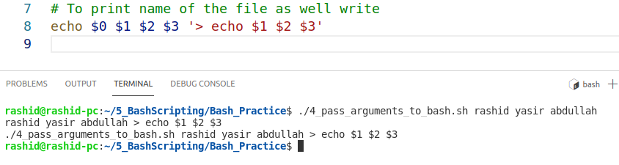

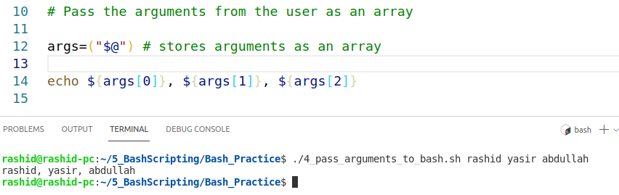

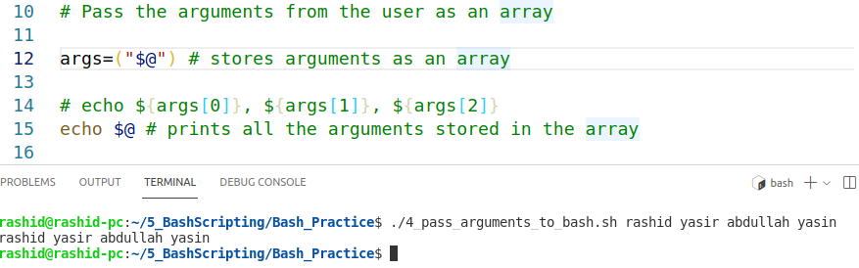

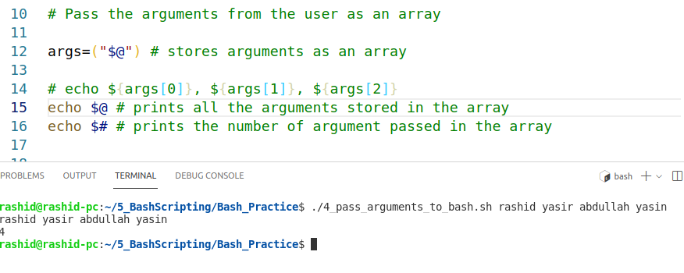

**5. Conditional Statements**

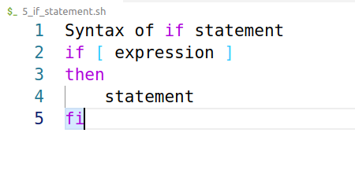

## Comparison Operators

### Integer Comparison

**-eq** is equal to **if [ "$a" -eq "$b" ]**

**-ne** is not equal to **if [ "$a" -ne "$b" ]**

**-gt** is greater than **if [ "$a" -gt "$b" ]**

**-ge** is greater than or equal to **if [ "$a" -ge "$b" ]**

**-lt** is less than **if [ "$a" -lt "$b" ]**

**-le** is less than or equal to **if [ "$a" -le "$b" ]**

**<** is less than (within [double parentheses](https://tldp.org/LDP/abs/html/dblparens.html)) **(("$a" < "$b"))**

**<=** is less than or equal to (within double parentheses) **(("$a" <= "$b"))**

**>** is greater than (within double parentheses) **(("$a" > "$b"))**

**>=** is greater than or equal to (within double parentheses) **(("$a" >= "$b"))**

### String Comparison

**=** is equal to **if [ "$a" = "$b" ]**

|  |  |
| --- | --- |
|  | Note the [whitespace](https://tldp.org/LDP/abs/html/special-chars.html" \l "WHITESPACEREF) framing the **=**.  **if [ "$a"="$b" ]** is not equivalent to the above. |

**==** is equal to **if [ "$a" == "$b" ]**

This is a synonym for =.

|  |  |  |
| --- | --- | --- |
|  | The == comparison operator behaves differently within a [double-brackets](https://tldp.org/LDP/abs/html/testconstructs.html" \l "DBLBRACKETS) test than within single brackets.   |  | | --- | | [[ $a == z* ]] # True if $a starts with an "z" (pattern matching).  [[ $a == "z*" ]] # True if $a is equal to z* (literal matching).  [ $a == z* ] # File globbing and word splitting take place.  [ "$a" == "z*" ] # True if $a is equal to z* (literal matching).  # Thanks, Stéphane Chazelas | |

**!=** is not equal to **if [ "$a" != "$b" ]**

This operator uses pattern matching within a [[[ ... ]]](https://tldp.org/LDP/abs/html/testconstructs.html" \l "DBLBRACKETS) construct.

**<** is less than, in [ASCII](https://tldp.org/LDP/abs/html/special-chars.html" \l "ASCIIDEF) alphabetical order

**if [[ "$a" < "$b" ]]**

**if [ "$a" \< "$b" ]**

Note that the "<" needs to be [escaped](https://tldp.org/LDP/abs/html/escapingsection.html" \l "ESCP) within a **[ ]** construct.

**>** is greater than, in ASCII alphabetical order

**if [[ "$a" > "$b" ]]**

**if [ "$a" \> "$b" ]**

Note that the ">" needs to be escaped within a **[ ]** construct.

See [Example 27-11](https://tldp.org/LDP/abs/html/arrays.html" \l "BUBBLE) for an application of this comparison operator.

**-z** string is *null*, that is, has zero length

|  |
| --- |
| String='' # Zero-length ("null") string variable.  if [ -z "$String" ]  then  echo "\$String is null."  else  echo "\$String is NOT null."  fi # $String is null. |

**-n** string is not *null.*

|  |  |
| --- | --- |
|  | The **-n** test requires that the string be quoted within the test brackets. Using an unquoted string with *! -z*, or even just the unquoted string alone within test brackets (see [Example 7-6](https://tldp.org/LDP/abs/html/comparison-ops.html" \l "STRTEST)) normally works, however, this is an unsafe practice. Always quote a tested string. |

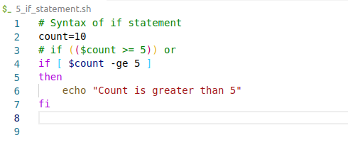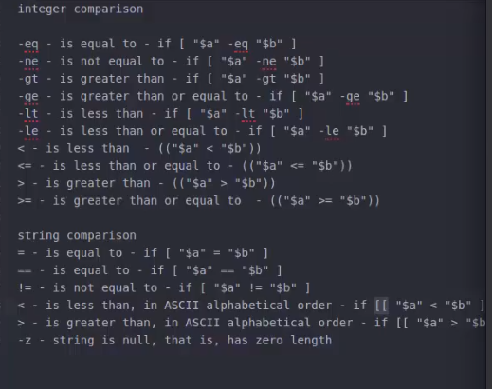

OR

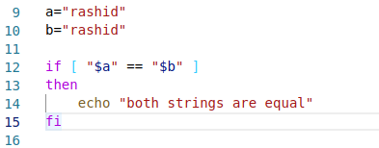

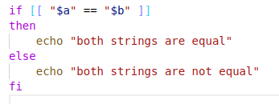

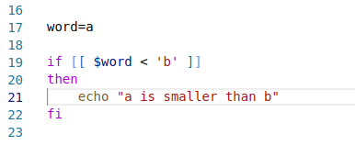

* use double brackets when you are using angle brackets (>,<) i.e., (( )) in case of comparing integers, and [[]] in case of comparing strings
* **Convention** that I will follow….
  + For strings, always use [[ ]] with comparison operators like ==, > etc
  + for integers, always use [] and use urinary operator like -eq, -gt etc.

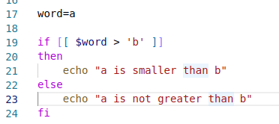

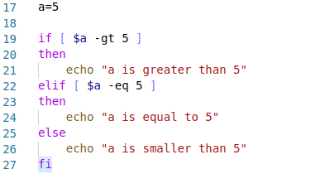

**6. File Test Operators**

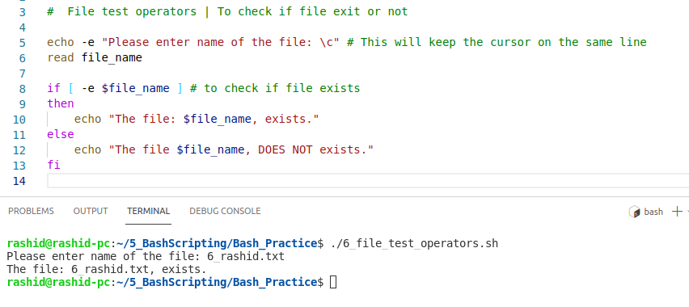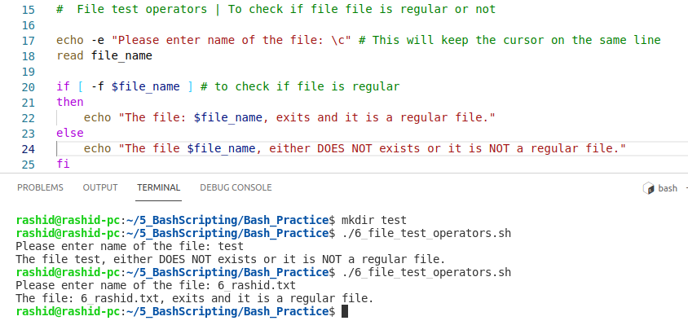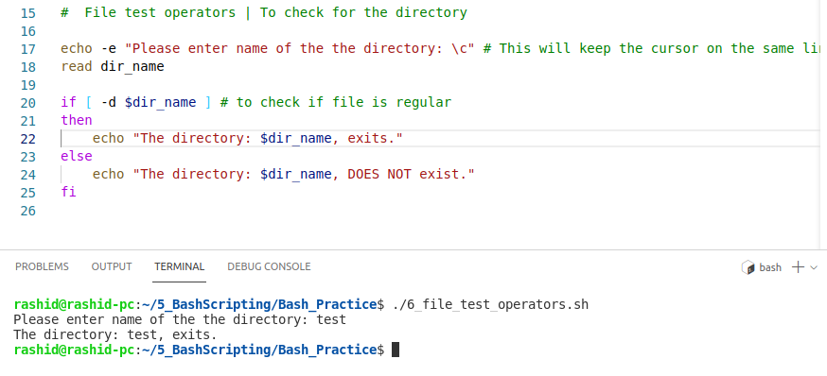

* Two types of files
  + character special file: normal file (**-b**)
  + block special file: binary file (**-c**)
* To check whether file is empty or not (**-s**)
* To check whether file has read, write, executable permission (**-r**, **-w, -x**)

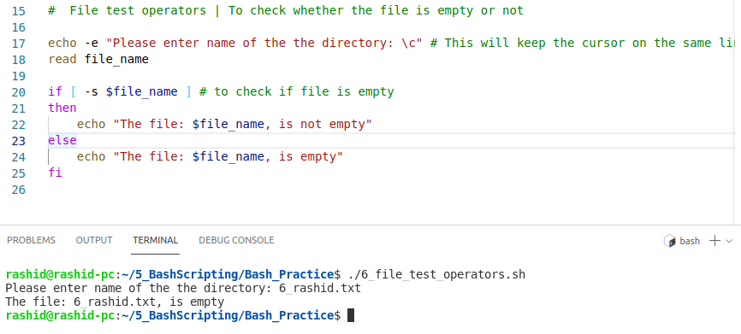

**7. How to append output of the end of the file**

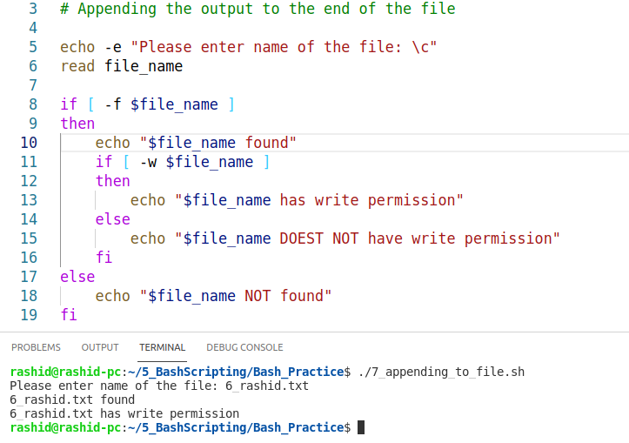

* cat > : will over-write the file
* cat >> : will append the data at the end of the file

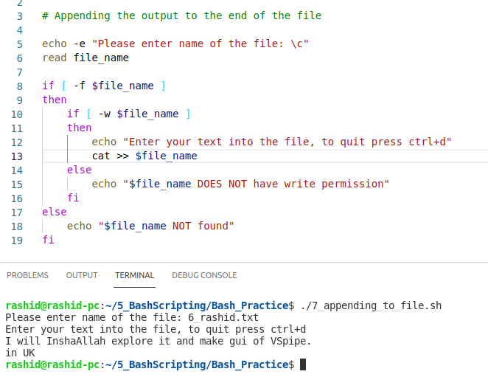

**8. Logical ‘AND’ Operator**

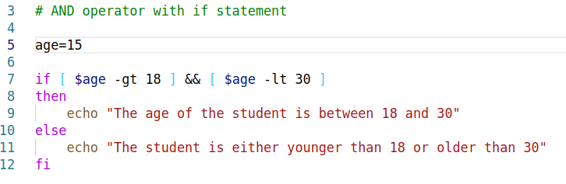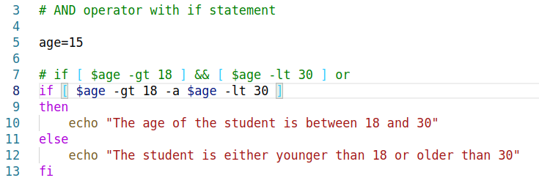

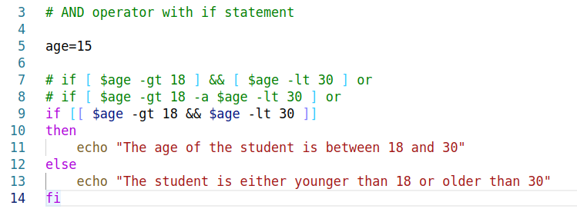

**9. Logical ‘OR’ Operator**

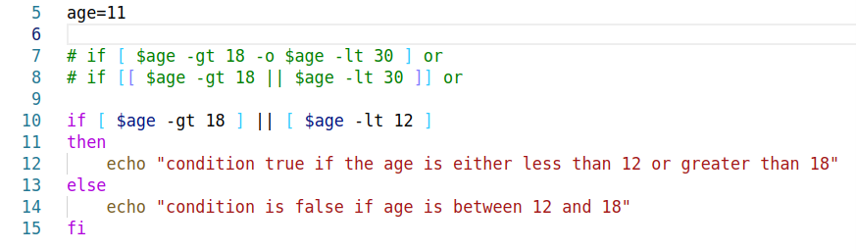

**10. Perform Arithmetic Operations**

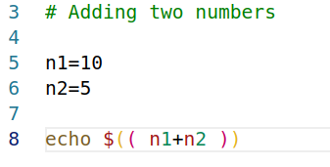

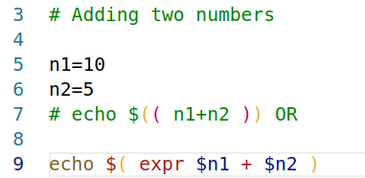

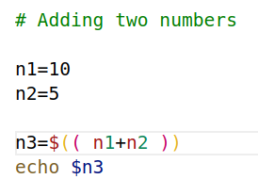

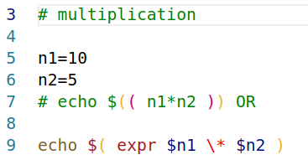

**11. Floating point math operations in bash | bc command**

* **echo "10.5+5" | bc**

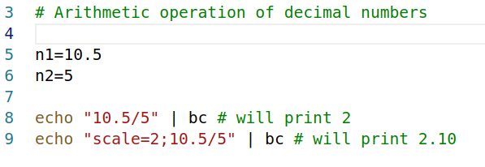

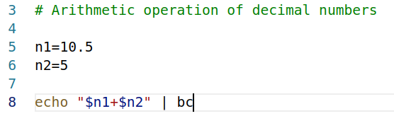

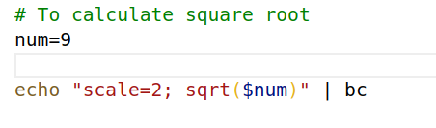

* echo "scale=2; 3^3" | bc

**12. The Case Statement / 13. The Case Statement Examples**

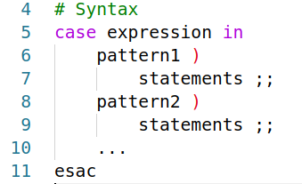

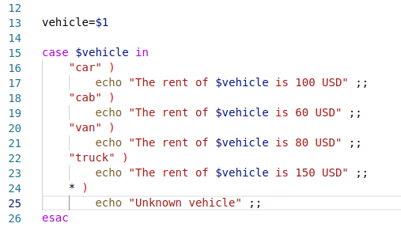

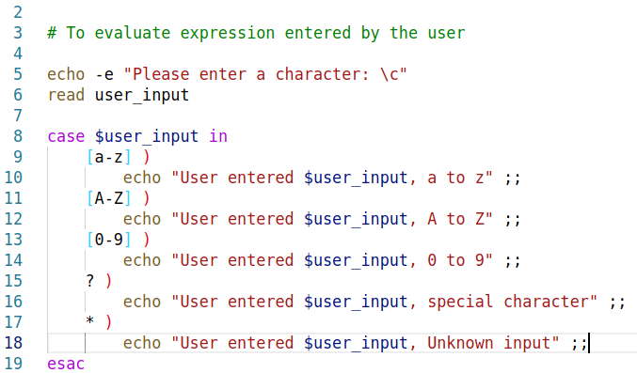**14. Array Variables**

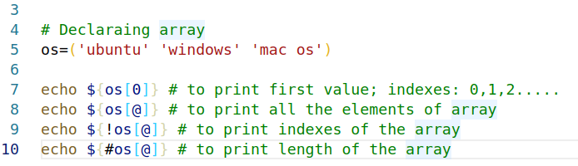

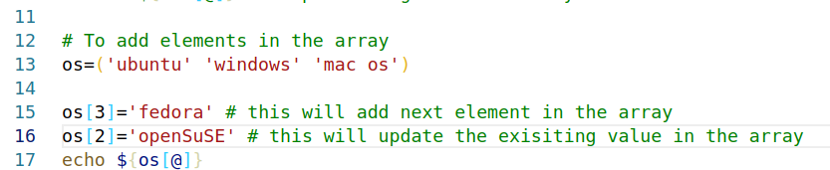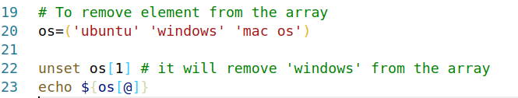

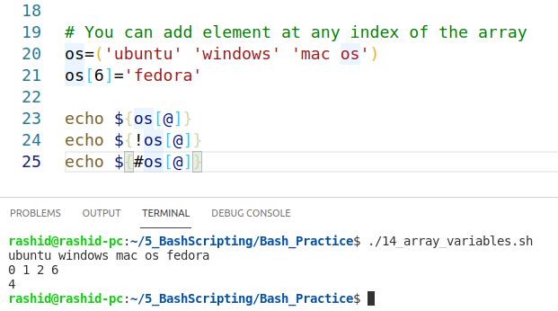

* Above code means that some indexes in the array may be left UN-initialized and gaps in the array are OK.

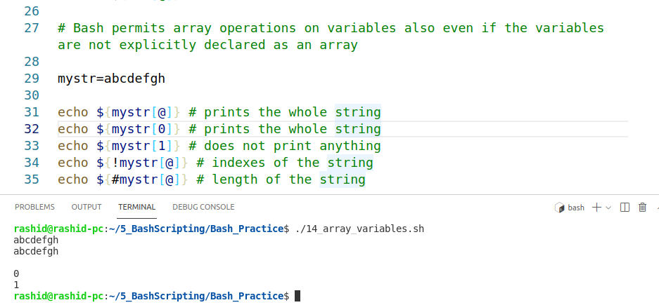

**15. WHILE Loops**

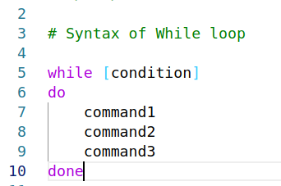

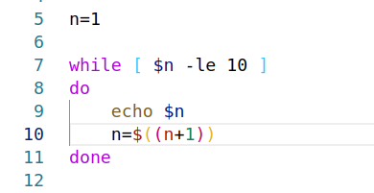

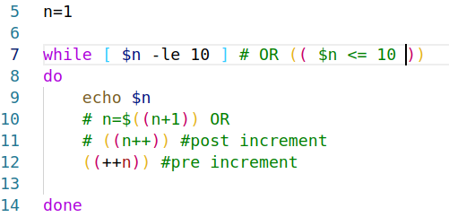

**16. Using sleep and open terminal with WHILE Loops**

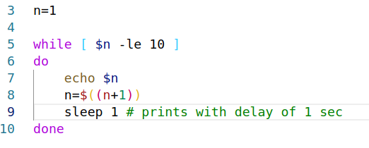

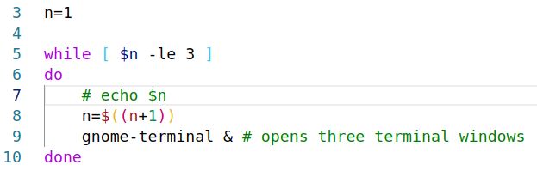

**17. Read a file content in bash**

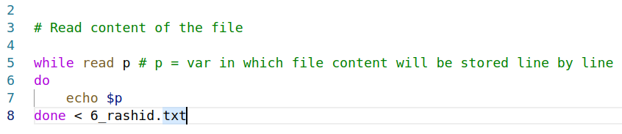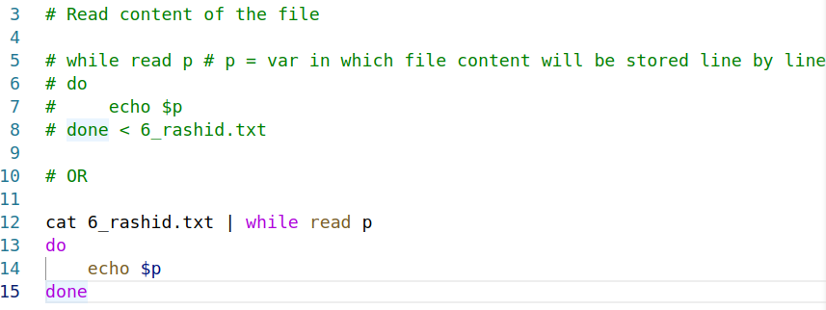

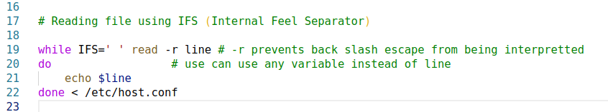

**18. UNTIL loop**

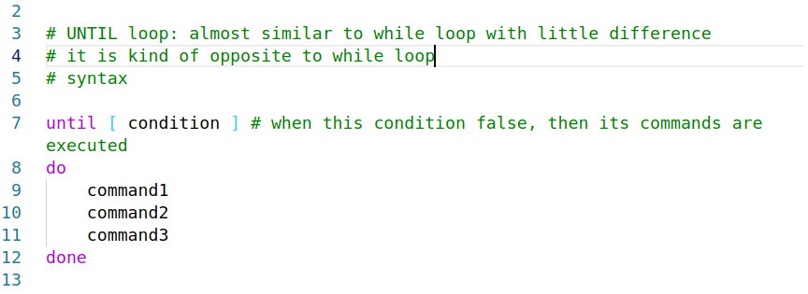

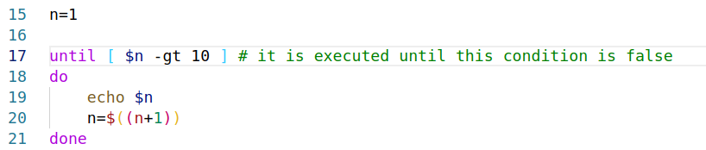

**19. FOR loop**

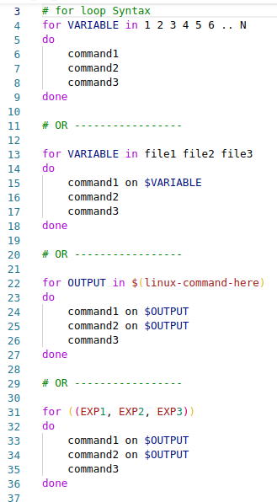

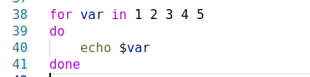

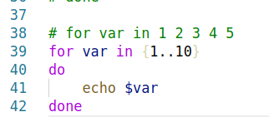

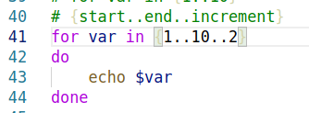

* echo ${BASH_VERSION}

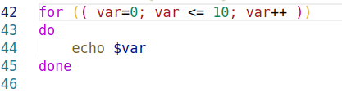

**20. FOR loop to execute commands**

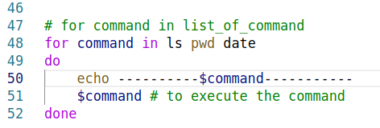

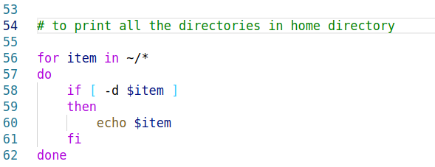

**21. Select Loop**

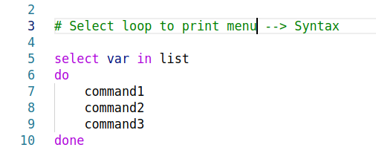

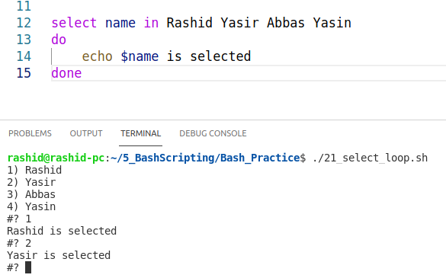

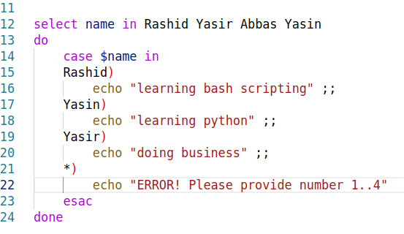

**22. Break and continue statement**

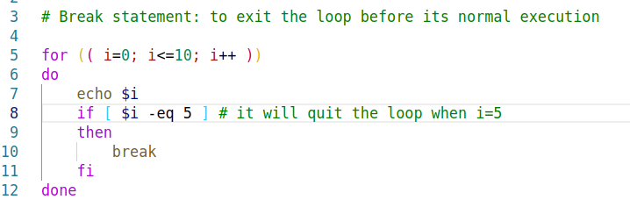

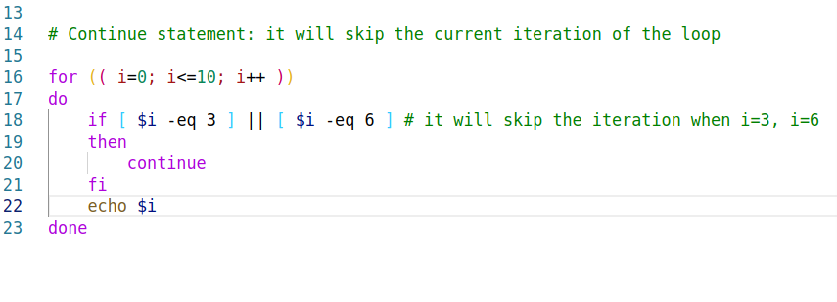

**23. Functions**

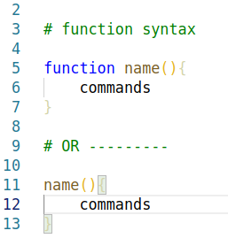

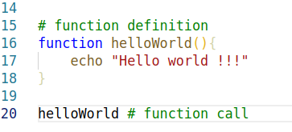

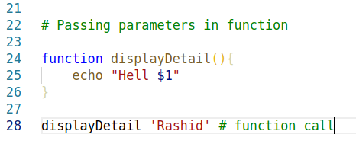

**24. Local Variables**

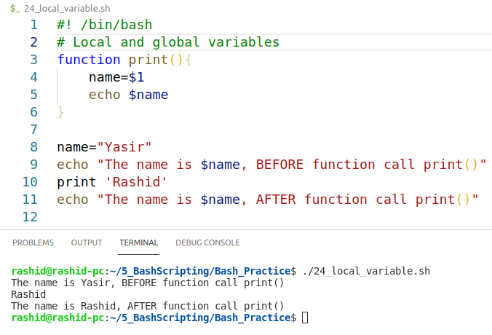

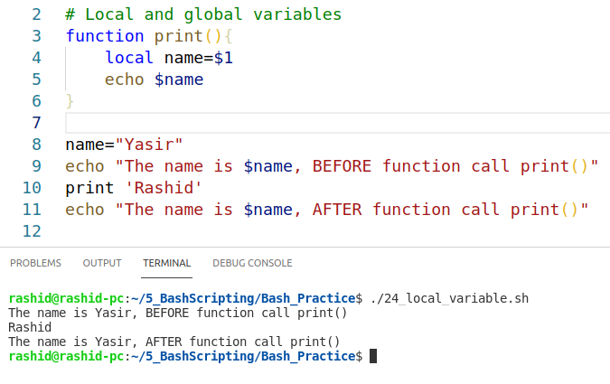

**25. Function Examples**

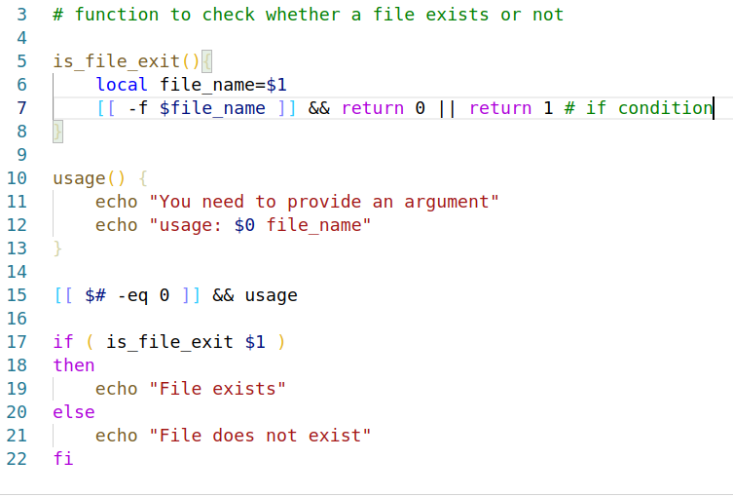

**26. Read only command**

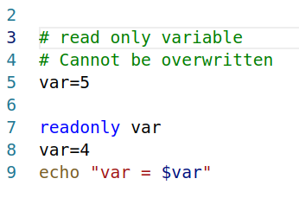

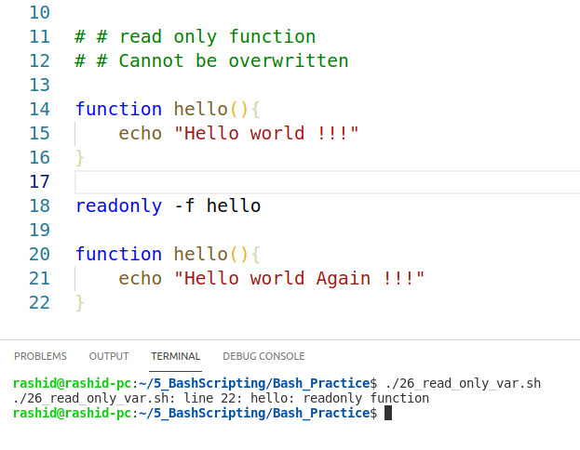

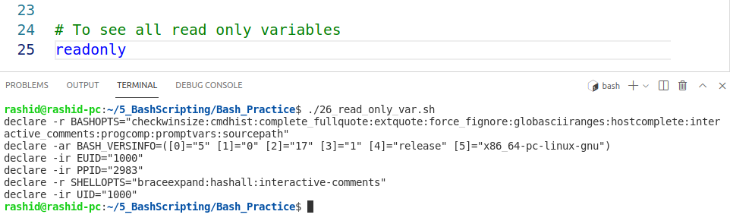

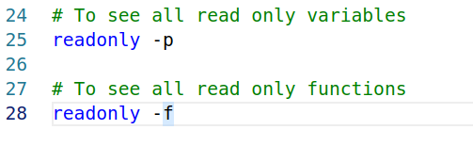

**27. Signals & Trap**

* To kill the process
  + kill -9 pid
* '$$' to print pid of the script itself
* to check about different signals
* man 7 signal
* simicolon is used to combine two commands

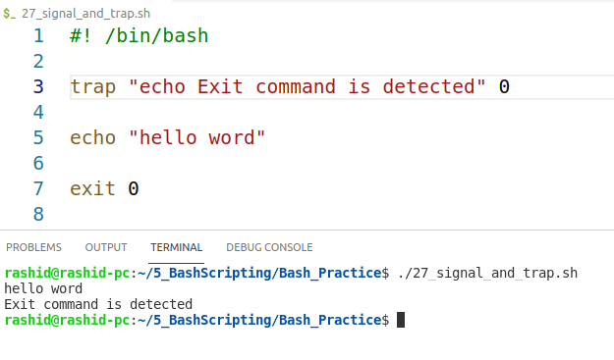

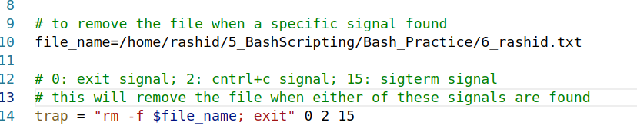

* to see trap that you have defined
* type trap
* to remove trap
  + trap - name_of signal/number_of_signal e.g. trap – 0 2 15

**28. Debug a bash script**

* bash -x ./script_name.sh OR
* #! /*bin/*bash -x (in the script) OR
* type set -x (in the script), it will start debugging from the point where you define this
* type set +x (in the script), it will deactivatedebugging from the point where you define this